Codes on collection

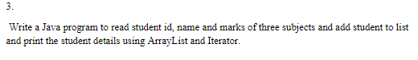

Codes:

import java.util.\*;

public class ArrayIter {

    public static void main(String[] args) {

        // Create and populate the list

        ArrayList<String> list = new ArrayList<>();

        Scanner sc = new Scanner(System.in);

        System.out.println("Enter students detail : StudentID, Name and marks of three subject:");

        list.add(sc.next());

        list.add(sc.next());

        list.add(sc.next());

        list.add(sc.next());

        list.add(sc.next());

        sc.close();

        // Displaying the list

        System.out.println("The list is: \n" + list);

        // Create an iterator for the list

        // using iterator() method

        Iterator<String> iter = list.iterator();

        // Displaying the values after iterating

        // through the list

        System.out.println("\nThe iterator values" + " of list are: ");

        while (iter.hasNext()) {

            System.out.print(iter.next() + " ");

        }

    }

}

Output:

